THE REFORM OF THE LEBANESE PUBLIC ADMINISTRATION IN THE FRAMEWORK OF THE CHANGING ROLE OF THE STATE

[**Issue Number 93 - July 2015**](https://www.lebarmy.gov.lb/en/content/93-d)

**The Reform of the Lebanese Public Administration in the framework of the changing role of the State**   
Prepared By: Dr. Georges Labaky   
Professor at NDU

**Introduction**

The development of the state and of its public services since the crisis of 1929 was the reflection of the belief in “the infallibility of the State” that  provides education, transport, control  markets, organize industrial activities and liberal professions, protect from financial risks, unemployment, educates, preserve the cultural heritage and makes itself, occasionally, industrial and/or tradesman. In order to achieve those objectives, the state had at its disposal exorbitant legal prerogatives, faced with a citizen considered as a passive subject. This conception of the public sector has been predominant until quite recently. Nevertheless, this notion of the public service, which can be defined as the accomplishment of a general interest mission, has been in a state of crisis for several years, at a time when in parallel, the private enterprise is endowed with all the virtues. During 1980s and 1990s New Public Management  doctrines dominated public management reform in Britain, Canada, New Zealand, and the United States as well as in some third world highly indebted countries where NPM reforms were dictated by international  donors and Western countries. New Public Management is  presented as a global reform movement. New Public Management (NPM) focuses on increasing public sector efficiency through a split with ‘traditional models’ of public management and governance. Instead of viewing the public sector as different from the private sector, it is based on the notion that business models of management are superior and the public sector will gain from imitating the private sector. As such, reforms of public administration have increased their focus on performance measurement, output controls, competition and private sector management practices. However, the definition and implementation of NPM-style reforms are influenced by domestic culture, institutional settings and administrative law traditions. Therefore its implementation has differed substantially across countries often with mixed results.

**I -The evolution of the role of the State**

Nowadays, the public sector is submitted at the same time to criticism as well as challenges.  The main criticism directed at the public sector is related to the waste of resources and the mediocrity of public relations with the citizens. In fact, the accusations of a state which spends money excessively, and the existence of long waiting lines at the government offices, are part of the collective representations and the public administrative. Beyond the perception and the formulation that the citizens have of the state, the latter is undeniably confronted to a series of major challenges that force the administration to undergo a global change and to transform its functioning modes. These problems, as well as the enormous successes over the preceding three decades, led for the re-examining the role of the state, by re-asking not only what the government should be doing, but also how it should do it, and perhaps most importantly  how these decisions are made.

The actual context of public budget deficits (state, public enterprises, welfare agencies…) and the weight of the public debt is accompanied by a will to reduce the spending of the public sector.  On the other hand, administrative  activities come within the context of a growing complexity.  This renders interventions by the public force more and more delicate. In brief, the administration has to move from a simple, uniform and statutory treatment, to complex, personalized and quasi-contractual answers.

The growing attitude of the users demanding more and more quality goods and services constitute another challenge to the public organisms, and this new consumerism seems to have changed profoundly enough the nature of the relations of the public establishments with the users.  Influenced by an environment of mass consumption, the user accosts public services with the same referents that guide his daily consumption of multiple products offered to him by the market.

It, thus seems that by their new attitudes, users and civil servants are forcing public enterprises to review their modes of functioning and organization.  The introduction, two decades ago, of new technologies has been another challenge thrown at the public sector. Gradually, as the competency domains of the administration grew beyond bureaucratic functions, certain forms of competition slipped little by little into the private sector. This is how competition between the public sector and the private sector came to exist in a number of domains such education, and health where for example hospitalization can be secured by public hospitals as well as by private establishments.

This competition can also exist within the public sector. Public agencies are in permanent competition to attract a much more mobile clientele than in the past, and to thus justify their existence. This legitimacy crisis of the public service is also accompanied by that of the general interest notion.

**a- The general interest notion crisis**

Several authors refer expressly to the notion of general interest which is  defined as the exercise of a general interest mission, and that  is the fundamental condition for the existence of a public service.  For sure, other criteria have to be pointed out, especially since they are not neutral regarding the management of public organizations: the right of inspection over the modalities of the mission’s accomplishment, the prerogatives of public power devolved unto the organization that manages the public service, and a  supervisory power over the administration in return for all those prerogatives.

 If the public service can be defined as being the product of a general interest mission, one incertitude subsists regarding the frontiers of the service in question: should we or should we not include in it activities such as water distribution, car production, or funeral services?

Progressively, and during the last decade specifically, the national general interest has been more and more in competition with the concept of efficiency and productivity. Countries with strong commitment to the notion of public service such as the European Union were led to abide by competition rules. European  Public enterprises submit to the competition rules in terms of Article 222 of the Rome Treaty. The result is that the competition policy applies under the same conditions to the private as well as public enterprises, including those entrusted with a public service mission. Articles 85,86, 90.1, and 92 of the Treaty of Rome forbid concerted understandings and practices or abuse of dominant position among the enterprises.  Article 90.2 of the Treaty of Rome stipulates that “the enterprises charged of the management of general economic interest services or presenting the character of a fiscal monopole is submitted to the rules of the present Treaty, notably to the rules of the competition, in the limits where the application of these rules put not a stop to the achievement in right or makes so of the particular mission that is given. The development of the exchanges must not be affected in a measure contrary to the interests of the Community”[[1]](https://www.lebarmy.gov.lb/en/content/reform-lebanese-public-administration-framework-changing-role-state" \l "_ftn1" \o ").

As for the member States, any aid or state resource likely to distort competition by favoring certain enterprises or certain productions are also forbidden even if article 90.2 of the Treaty of Rome brings forward some arrangements regarding the particularity of public services: “The enterprises entrusted with the management of a general economic interest service or showing characteristics of a fiscal monopoly are submitted to the rules of the present treaty, notably the rules of competition to the point where the application of such rules does not lead to the failure of  the particular mission they have been assigned.”It is within this framework that a certain number of French public services have gone through the community requirements, incontestably rigorous with regard to the habits previously contracted by the operators involved. The EU competition Commissionner has not kept secret his ambition to break up the public service monopolies even if the governments oppose it by setting minimal governmental obligations toward public enterprises. Thus, to get derogations to the rules of the competition the public service must demonstrate that its task is not only difficult but insurmountable or even impossible.

Faced with this crisis of legitimacy, the private enterprise is endowed with all the virtues. Thus, the renovation of the public service was done within a hostile ideological context.  Whereas in the 80s, the State was considered the motor of social change, it is often considered nowadays as a brake to the innovation, and a handicap to the economic competition.  On the contrary, the private enterprise which up till the eighties was considered with defiance finds itself endowed with all the virtues. In fact, as shown by J.P. Le Goff in his books “The Myth of the Enterprise” and “The Illusions of Management”, since the 1980s the private enterprise concept has grown to the dimension of a real myth, quasi-untouchable.

On the other hand, the media tend to give a caricatured image, opposing dynamic, performing, and private enterprises on one side, and sclerosis counterproductive public services on the other side. Therefore, the manifestations of the triumphant enterprise myth are numerous and spectacular.  Within this context, in the 1980s, a new managerial current has largely developed itself within the private sector. Management claims to reconcile in a vast and harmonious synthesis, the economic, the social and the cultural and by making sure that the objectives of the modern enterprise are shared by all, in order to increase productivity and quality.

Thus, the temptation was inevitable to use tools and management techniques of the private sector in order to improve the public sector’s functioning. For certain authors, inspired by the Anglo-Saxon literature in this domain, such as Florence Maas for example, in her book entitled “Private Management for Public Services: Managing the Administration” the outcome for public administration will come through the interconnection of private management techniques, and those of the public service.  Therefore, those two worlds are getting closer and closer and the distinction between private and public management has less and less meaning. Within this framework, a new actor appears: the client.

However, the public administration was opposed to the logic of the market because of its traditional monopoly situation. It imposed its rules to the  citizens.

This traditional attitude has less and less reasons to exist; faced with the competition, the  public administration has to justify its superiority by best responding to the needs of the user, who is on the way of becoming a real client, free to exercise his choices.  One of the fundamental reasons for this mutation can be found in what is called the “legitimacy crisis of the public sector”.  According to its authors, the objectives of the public service are more and more uncertain. In order to regain some legitimacy, the administration has to seduce its public, adjust to its demands and make the services it proposes adequate to the demand.

**b- New Public Management principles**

The New Public Management (NPM) seeks to offer more efficient mechanism for delivering goods and services and for raising governmental performance levels through  the use of Market-type Mechanisms, Managerial improvement and Organizational Restructuring, and the Focus on Performance. The following tools are applied:

- Managers at the top of the organization are free to manage by use of discretionary power.

- Explicit standards and measures of performance; Goals and targets defined and measurable as indicators of success. Accountability means clearly stated aims; efficiency requires a ‘hard look’ at objectives.

- Greater emphasis on output controls.

-Resource allocation and rewards are linked to performance.

-Need to stress results rather than procedures.

- Shift to disaggregation of units in the public sector.

- Shift to greater competition in the public sector.

-Moving to term contracts and public tendering procedures; introduction of market disciplines in public sector.

- Stress on private-sector styles of management practice.

-Moving away from traditional public service ethics to more flexible hiring rules.

Osborne and Gaebler (1992), in their book “Reinventing Government”, put forward ten principles that will induce an entrepreneurial spirit in the Public Sector. The following principles are capable of reinventing the government.

These tools are:

a. Catalytic government: steering rather than rowing

b. Community-owned government: empowering rather than serving

c. Competitive government: injecting competition in service delivery

d. Mission-driven government: transforming rule-driven organizations

e. Results-oriented government: funding outcomes, not inputs

f. Customer-driven government: meeting the needs of the customer, not the bureaucracy

g. Enterprising government: earning rather than spending

h. Anticipatory government: prevention rather than cure

i. Decentralized government: from hierarchy to participation and teamwork[[2]](https://www.lebarmy.gov.lb/en/content/reform-lebanese-public-administration-framework-changing-role-state" \l "_ftn2" \o ")

Other  studies on NPM had mentioned five core principles that rely heavily on business and entrepreneurial cultural in public organizations and aim at minimizing the size and scope of governmental activities:

(1) Downsizing: reducing the size and scope of government

(2) Managerialism: using business protocols in government

(3) Decentralization: moving decision making closer to the service recipients

(4) Debureaucratisation: restructuring government to emphasize results rather than processes

(5) Privatization: directing the allocation of governmental goods and services to outside firms[[3]](https://www.lebarmy.gov.lb/en/content/reform-lebanese-public-administration-framework-changing-role-state" \l "_ftn3" \o ").

According to Arouajo the “The paradigm shift from public administration to new public management involves a move in the basic design co-ordinates of public sector organizations that become less distinctive from the private sector and the degree of discretionary power (particularly over staff, contracts and money) enjoyed by public managers is increased, as the procedural rules emanating from the centre are relaxed. Government reworks budgets to be transparent in accounting terms, with costs attributed to outputs not inputs, and outputs measured by quantitative performance indicators. Public sector organizations should be viewed as a chain of low-trust principal/agent relationships (rather than fiduciary or trustee-beneficiary ones) and a network of contracts linking incentives to performance. Government disaggregates separable functions into quasi-contractual or quasi-market forms, particularly by introducing purchaser/provider distinctions; opens up provider roles to competition between agencies or between public agencies, firms and not-for-profit bodies; and deconcentrates provider roles to the minimum-feasible sized agency, allowing users more scope for ‘exit’ from one provider to another, rather than relying on ‘voice’ options to influence how public service provision affects them.” [[4]](https://www.lebarmy.gov.lb/en/content/reform-lebanese-public-administration-framework-changing-role-state" \l "_ftn4" \o ")

**II -The reform of the lebanese public administration: a top priority**

It is quite clear that the issue of administrative reform in Lebanon is urgency. Failure to address this problem as soon as possible carries great risks for the future of the country. There is a strong need to modernize and reform the public administration in order to make it able to face the different challenges faced by Lebanon internally and externally.

The reform of the Lebanese public administration is necessary to restore  public confidence in it, and promoting greater political stability. There is no doubt that the difficult condition of the public administration is the result of the war as well as the lack  since 1959, of  any serious and effective attempts to reform and improve its public administration. Since more than half a century, Ministries and public agencies have been established  without much reference to any  kind of planning. This absence of policy making and implementation, and the poor accountability of the public sector undermined  the government public service performance.

Thus, in its present form the public administration in Lebanon is not an adequate vehicle to deal with the  tremendous tasks its facing such as the public debt issues, the reconstruction of the country, and the  economic crisis is looming because of the regional instability. The unresponsiveness of the administration is due its centralized nature and tortuous decision making process. There is no alternative to the reform and modernization of the Lebanese public administration.The means used for such reform were introduced through legislative decrees. New strategies and procedures may be needed to impose if necessary reforms. On the other hand, priorities are to be carefully defined for it is impossible to carry on all necessary reforms at the same time.

As such, it is necessary to carry on the following steps:

**a- Political will**

Bureaucracy is entangled in politic:  Administrative reform is a political activity that attempts to change the power structure in a certain society. Administrative reform is power politics in action. Proponents of this point of view do not totally reject the managerial content of reform, but they argue that the goals of reform, are used to advance other hidden agendas, namely political. Reformers will not get anywhere if they define administrative problems only as apolitical matters.  What underlies reform is a more fundamental issue: The exercise of power. Bureaucracy is very much about power; it is thus eminently political.

Consequently any reform attempt is the subject of intense confrontation, compromise and bargain between  politicians and  bureaucrats. Max Weber was the first scholar to realize this potential conflict between elected politicians and appointed bureaucrats. Administrative reform involves three major groups of players. The first is the politician involved in promoting or resisting reform (according to his political interests). The second is the  bureaucracy that considers a successful reform is the one that strengthen its position at the expense of the politicians’. The third  group is the public. While  politicians feel like the need to implement quick fixes and perceive bureaucracy as an obstacle to quick change, bureaucrats rely on their technical superiority, information, power of decision, and political support. Politicians resort to their power of legislation, budget, and politically motivated employees from inside the administration.

In the past years, there has not been in Lebanon enough political support to pursue a serious administrative reform and to alleviate the pressure on the administration to improve its performance and  accountability. Changes did not tackle the strategic and structural problems related to the legal mandate of institutions nor did they provide a clear and firm Government’s vision on the overall mission of  the Lebanese public administration. In fact, the emphasis has been more on rehabilitation and modernization, and much less on reform. Moreover,  many  promises and official statements were issued, without being  implemented.

(1) The adoption of  strategic planning at the level of the State as well as every at every government agency. In the current situation of the Lebanese Public sector, public policies are usually poorly conceived and outdated  due to the legal perspective approach of the public sector.  In fact, a limited number of public administrations are familiar with strategic planning. Moreover, there is a lack of policy- making capabilities, including lack of relevant data,  and of management information systems, which can provide the  data  needed to make sound  decisions. Also, evaluation and monitoring are poorly developed and there is very little feedback of government policies . Since the war, policies are very often not linked to a larger vision on the role of the State. There is a tendency to deal on  a case by case  basis and to act under the pressure of the political or economic situation. It is vital that  every public administration come up with some kind of strategy for its work and defines a clear mission and vision.

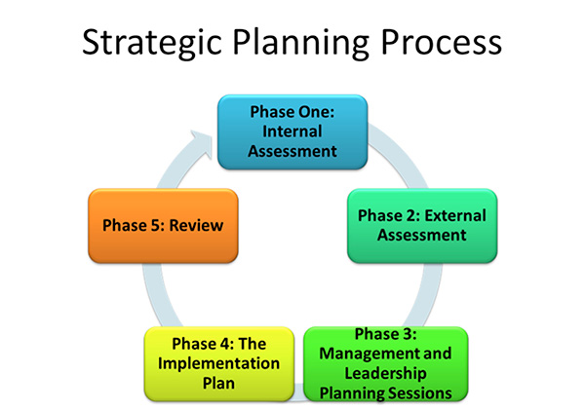

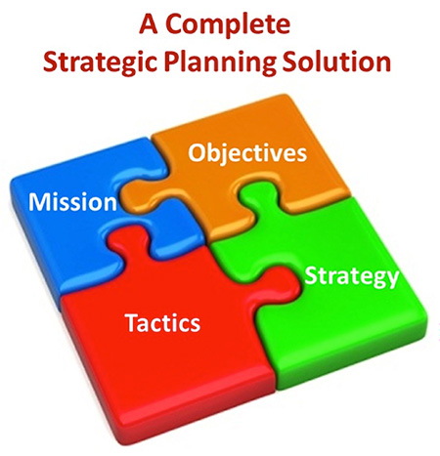

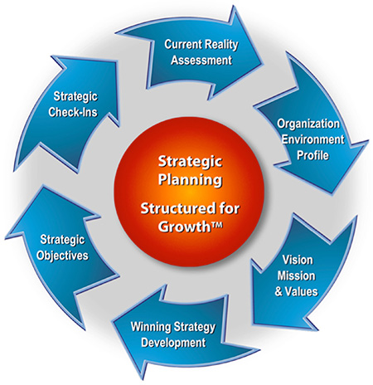

(2)The move from a procedural administration to a responsibility administration.

In the early 1970s, the notion of management appeared to several officials as scandalous and inacceptable.  Nowadays, public management has become an official policy of numerous countries.  Considerable efforts have been made by several countries in view of reinforcing public management.  The pursued objectives included the increase in productivity, the improvement of quality  in accordance with citizens’ demands, and the modernization of  tools of control specially at the budgetary level. This  policy aimed at making  the administration more efficient. The aim was not in as much to have less government but   better government.

(3) Partnerships between public and private sector and the search for formulas of balanced cooperation between public and private organizations. “Government functions should promote and facilitate private sector development, while safeguarding social interests. To advance social and economic development, tailored partnering arrangements between public and private sector are essential in order to improve service delivery of public goods by using the higher efficiency of the private sector in many operational fields. This can take many forms, reflecting the nature of the activities, strength of commercial agencies and the capacity of the State.”[[5]](https://www.lebarmy.gov.lb/en/content/reform-lebanese-public-administration-framework-changing-role-state" \l "_ftn5" \o ")

(4) The regaining of public service legitimacy through redefining the relationship with the users through the encouragement of competition. Thus,  the public administration should  move from a situation of monopoly to real competition and thus giving the freedom of choice to consumers.

The  endemic poor performance of the public administration, and widespread  beliefs regarding corruption, has further contributed to the development of such a profound distrust that it has become difficult to persuade the public that improvements are at all possible. “The concept of client-responsiveness of public administration implies a basic shift from a bureaucratic structure to an open-system approach. Responsiveness in public administration should be a principle that links the administration to its clients, thereby safeguarding the quality, accessibility and transparency of public service delivery. It means that government measures are informed and guided by the needs of citizens and take into account the changing priorities and resources of these citizens. Citizens need to be able to understand the decision making processes that affect them and to articulate their needs, regardless of social, ethnic or political backgrounds.”[[6]](https://www.lebarmy.gov.lb/en/content/reform-lebanese-public-administration-framework-changing-role-state" \l "_ftn6" \o ")

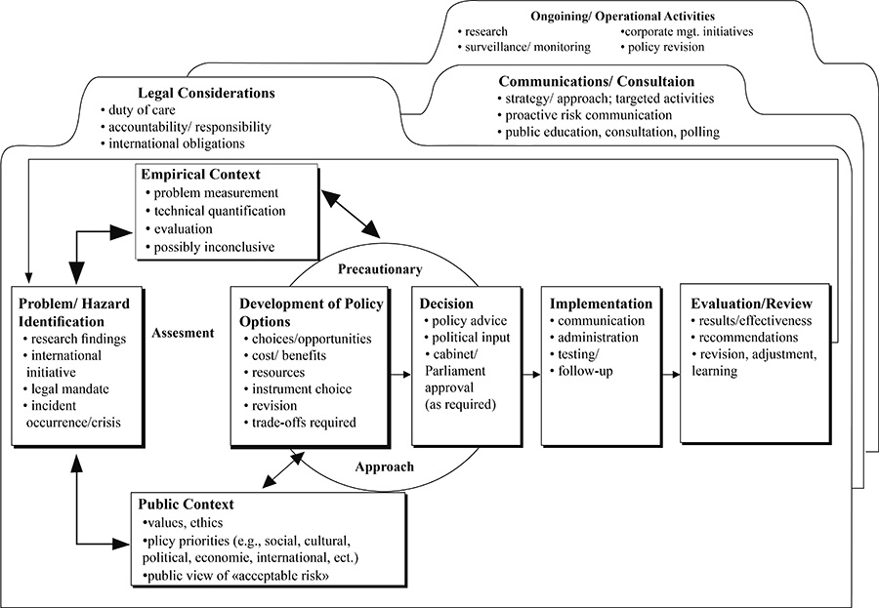

-The development of a framework for a Human Resources Management and Development approach and establish capacities for HRD and HRM at the level of ministries and public agencies. This entails the following:

●Focus the role of the State on core functions and tasks.

●Ensure effective and coherent structures of the public administration.

●Strengthen policy making and implementation capacity

●Ensure high quality civil service and civil servants

●Streamline and modernize procedures and systems

●Enhance the quality of governance

●Improve client and result orientation.[[7]](https://www.lebarmy.gov.lb/en/content/reform-lebanese-public-administration-framework-changing-role-state" \l "_ftn7" \o ")

●Develop new legislations on the civil service, stressing accountability and introducing greater flexibility and stronger performance orientation

●Introduce a recruitment/selection system and a career development system exclusively based on merit, with a simple grading and ranking system

●Introduce a transparent and objective performance measurement system, regarding quality and productivity of civil servants

● Introduce common standards in civil service, a common job description program for all public servants and a broader scope for inter-ministerial mobility of staff

●The shift from a traditional administration emphasizing on rules and procedures towards a modern administration focusing on results and achievements of objectives, as well as on networking, strategic policy and planning skills.

●Provide for  quality training  of civil servants within the framework of flexible career development plans and allowing lateral transfers;  Open new channels for recruitment of higher level staff, especially from private sector backgrounds.

●The reorganization of the public service and its structure for there are a large number of vacancies and inadequate distribution of employees.  Moreover, there are serious shortages within the public administration of certain important skills, especially in engineering, scientific and information technology skills, basically as a result of the fact that the private sector is able to offer these people much higher salaries. Many applicants join the government because of the job security that a civil service job guarantees. On the other hand, there are many temporary and daily workers who are mostly not recruited according to merit standards and can be considered as political appointee. There is significant overstaffing in those ranks those results in the weakening of the role of merit in matters of recruitment, mobility and employees careers.

●The complete reform of  the recruitment and testing system which is outdated and cannot reliably help in detecting necessary skills and abilities in various jobs, especially in the absence of a job description and classification system. Priority is to be given to competencies and not to formal exams.

**b-  Accountability**

The systems of control and accountability in both the political and administrative domains are highly ineffective. Legislative oversight of the public administration is absent and judicial control is difficult due to political patronage.  The controls and disciplinary agencies within the executive branch are having difficulties in curbing corruption and mismanagement within the public administration.

The obsolete and formal work methods and procedures add to citizen complaints, and in the most important cause of inefficiency and weak service delivery in the public administration. Work procedures emphasize on legality compliance and caution at the expense of initiative, speed, and efficiency.  Procedures and regulations should be entirely transparent. They need to, focus on results and accountability, and allow for flexible responses to a changing environment. Finally, the operational systems of the public administration suffer from insufficient technology and a very weak resource base. Information technology, which could be of tremendous value in increasing efficiency and transparency, is under-utilized. Data storage is often by hand, communication only by traditional means and the power of the Internet is not used for making the State accessible and comprehensible to the citizen, nor for providing opportunities to solicit inputs from citizens.

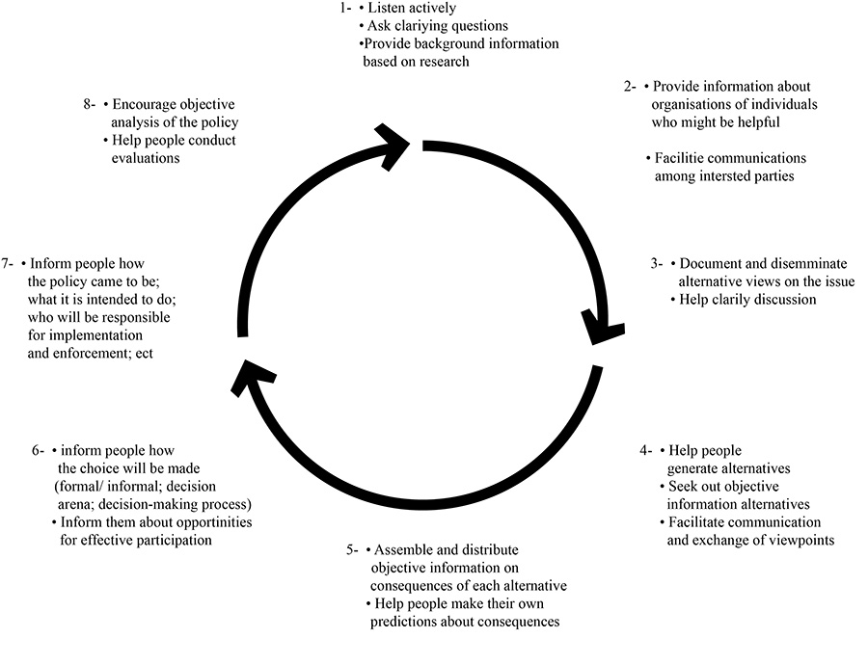

**Performance Appraisal Uses**

**.**Raises, Merit Pay, Bonuses

**.**Personnel Decisions (e.g, promotion, transfer, dismissal)

**.**Identification of training needs

**.**Reserach Purposes (e.g., assessing the worth of selection tests)

f) The need to protect, anchor and support the reform process: The reform process “will be confusing, difficult and, to a considerable extent, unpredictable. Without sufficient political stability and high level support it will fail. Also, it requires a proper institutional foundation. These challenges and difficulties can be reduced by: A   cross party support for the reform strategy. Through  intensive debate, exposure to other approaches in surrounding countries, training,  and use of mass media and mobilization of views and stirring debates in civil society; Anchored  the reform implementation in a competent organization that has a strong and specific mandate, political support and adequate resources. This the solution adopted by the European Union in Greece.

**CONCLUSION**

**a-Changing culture - Challenges faced by NPA**

The introduction of management tools which have, according to certain experts, destroyed the public services as a result of the disappearance of traditional and symbolic references was not achieved without some resistance. Civil servants have most often and in majority marked their attitude by a certain skepticism and retreat. As a whole, it appears that the characteristics of public organizations did not allow the total blooming of modern control tools. The transposition of such tools in public organizations has faced many difficulties. Bureaucracy has often constituted a barrier to the introduction of managerial tools of control. Mostly, operations linked to general interest missions present a character that can be measured with difficulty. For example, the hospitality activity in France has long been measured by the number of hospitalization days, thus allowing the establishment of the budget and served to determine the financial situation of the hospital. This system quickly revealed itself to be imperfect, the administrators and the doctors have sought to maximize the number of hospitalization days, which have led to an increased in costs of collectivity.

Since 1983, an analytical accountability has been promoted by the classification of sick people in homogeneous groups allowing the identification of the cost by major activity and responsibility criteria.

On the other hand, management, by its brutal approach of problems, encountered a certain a profound demotivation of a great part of personnel which have had the feeling of having participated in a swindle market.

In fact, it is indispensable that all modernization steps be based on time periods which offer a guarantee of stability. This poses in the private sector the problem of political piloting. When political majority changes in a democracy, it is often accompanied by a break or in the best of cases by a stagnation of the work launched by the precedent majority. Whereas the political objective clearly perceived by the agents and users seems as an indispensable condition for the success of all modernization steps.

As a whole, studies and evaluations have shown that the actions and initiatives have allowed for notable progress, in particular in the reception sectors, computerization, and constitution of collective projects…

However, such steps have often failed due to a lack of intention and imprecise aiming.

Public services should cultivate their specificity, which is the realization of general interest missions. The path may be in a modification of the relationship with the user, and in the search for the latter’s satisfaction. This process is not easy to achieve.

The process which personalizes the user leads us to question whether beyond the new relation with the client instituted by certain products, there does not exist a supplementary step which brings this time a modification of the initial definition of the public service. The fundamental problem posed by this kind of products is to know if they do not subvert the initial public service mission and if they do not question certain founding principles of public service, notably the equality of all users. This equality principle of the citizens is the constitutive principle of citizenship in democratic regimes, which assure every citizen an identical right to the definition of general interest. It guarantees a right to equal treatment for individuals, which has to be ensured by formal rules. This conception of equality as an identical treatment has founded and still largely founds our conceptions of public service.

The equality of treatment can be achieved in one of two ways:by the standardization of institutions, the definition of national norms applicable to all. Nevertheless, the differentiation leads us to call for another common good that that to which we referred before with the principle of equality of treatment. When we privilege the most under-privileged according the common good is related to social cohesion.The common good may be in conflict with the reference to equality of treatment.

**b- Changing environment and culture**

The Lebanese administration is faced with important challenges of different nature (competition, local powers, new technologies, consumerism…) which no doubt poses   serious problems. This crisis, gave room to various regulations, consultancies, reforms, and attempt of innovation. However, all those steps have often  failed due to the lack of clarification of public service objectives, which is related as much to politics as to stricto-sensu administrative management. Finally, the state must pull its legitimacy by the quality of the benefits that she assures to the users. This revolves around the following question: In what society do we want to live?

Faced with those rapid mutations, as much political as technological of the environment, the definition of a global vision of the society, the constitution of “sense” and “coherence” should be given priority.

The role of the public services as producers of social cohesion are strictly speaking here irreplaceable and no one can put back seriously in reason nor their legitimacy, nor their existence without making the choice of the economic cost against the social cost. It is not certain that the second is not more costly for the collectivity that the first one. Is one going to privilege the economic approach to the detriment of the social apprehension of the public service?  The response to this question is decisive to determine with public administration is to prevail.

There is a need to change people culture toward the public administration and work for promoting a modern efficient public administration. For “Civil society occupies the middle ground between the public and the private sector. Building civil society, and developing civic engagement and participative options for citizens and professional organizations are essential elements for ensuring legitimacy of public administration. The presence of a strong and vivid civil society is a precondition for ‘good governance’, as it helps to establish the countervailing powers that will correct the State or private sector. Good governance is characterized by openness, willingness to account, attention to all clients and adherence to agreed plans.”[[8]](https://www.lebarmy.gov.lb/en/content/reform-lebanese-public-administration-framework-changing-role-state" \l "_ftn8" \o ")

**Bibliography**

-Aberbach, J. & Rockman, B. (2000), **“In the web of politics: Three decades of the U. S. federal executive”**, Washington DC: Brookings.

-Araujo, J. (2001), **“Improving public service delivery: The crossroads between NPM and traditional bureaucracy”**, Public Administration. Vol. 79 (4)

-Argyriades, D. (2003), **“Values for Public Service: Lessons Learned from Recent Trends and the Millennium Summit”**, International Review of Administrative Sciences. Vol. 69(4): 521-33.

-Batley, R. & Larbi, G. (2004), **“The changing role of government: the reform of public services in developing countries”**, Public Administration and Development. Vol. 25 (3).

-Caiden, G. (1969), **“Administrative reform: American style”**, Public Administration Review. Vol. 54 (2): 322- 330.

-Christensen, T. & Per Lægreid, P. (2002), **“New public management: The transformation of ideas and practice**”, Aldershot: Ashgate Publishing.

Communications Manual (1996). Washington, DC: United States General Accounting Office.

-DeLeon, P. & Green, M. (2001), **“Corruption and the New Public Management”**, in Johns, L., Guthrie, J. & Steane, P. (Eds.) **“Learning from international public management reform”**, Emerald Group Publishing Limited.

-Denhardt, R. & Denhardt, J. (2002), **“The new public service: Serving rather than steering”**, Public Administration Review, Vol. 60 (6): 549-559.

-Dunleavy, P.; Margetts, H.; Bastow, S. & Tinkler, J. (2005), **“New public management is dead – Long live digital-era governance”**, Journal of Public Administration Research and Theory. Vol. 16 (3): 467-494.

-F-alconer, P.K. (1997), **“The New Public Management: Principles and Practice in the UK”**, Javna Upravna, 33, 1, 1997: 85-108.

-Tat-Kei Ho, A. (2002), **“Reinventing local governments and the e-government initiative**”, Public Administration Review. Vol. 62 (4): 434-444.

-Hood, C. (1991), **“A public management for all seasons?”**, Public Administration Review. Vol. 69 (1): 3-19. (1995), “**Contemporary public management: A new global paradigm?**”, Public Policy and Administration. Vol. 10 (2): 104-117

-Hughes, O. (2003), **“Public management and administration: An introduction”**, 3rd Ed. Palgrave: Macmillan.

-Light, P. (1997), **“The tides of reform: Making government work”**, New Haven, CT: Yale University Press.

-Mallon, R. (1994), **“State-owned enterprise reform through performance contracts: The Bolivian experiment, World Development”**, Vol. 22 (6): 925-934.

-Metcalfe, L. (1998), **“Accountability and effectiveness: Designing the rules of accounting game”**, Paper presented in International Conference on Accounting for the New Public Management, Venice.

-Moe, R. (1994), **“The Reinventing Government exercise: Misinterpreting the problem, misjudging the consequences”**, Public Administration Review. Vol. 54 (2): 111-122.

-OMSAR . Annual Reports. The Office of Minister of State for Administrative Reform. Beirut.

-Waldo, Dwight,**“The Administrative State Revisited”**, Public Administration Review 25, 1965, no. 1:5-30. -”

[[1]](https://www.lebarmy.gov.lb/en/content/reform-lebanese-public-administration-framework-changing-role-state" \l "_ftnref1" \o ")-   Article 92 of the Treaty of Rome creating the European Economic Market in 1957.

[[2]](https://www.lebarmy.gov.lb/en/content/reform-lebanese-public-administration-framework-changing-role-state" \l "_ftnref2" \o ")-   Osborne and Gaebler, **“Reinventing Government”**, Addison-Wesley Publishers, 1992.

[[3]](https://www.lebarmy.gov.lb/en/content/reform-lebanese-public-administration-framework-changing-role-state" \l "_ftnref3" \o ")-   Araujo, J.,**“Improving public service delivery: The crossroads between NPM and traditional bureaucracy”,**  Public Administration, 2001, Vol. 79, p.4.

[[4]](https://www.lebarmy.gov.lb/en/content/reform-lebanese-public-administration-framework-changing-role-state" \l "_ftnref4" \o ")-   Ibid.

[[5]](https://www.lebarmy.gov.lb/en/content/reform-lebanese-public-administration-framework-changing-role-state" \l "_ftnref5" \o ")-   OMSAR, “Strategy for the Reform and Development of  Public Administration in Lebanon” , Beirut, 2011.

[[6]](https://www.lebarmy.gov.lb/en/content/reform-lebanese-public-administration-framework-changing-role-state" \l "_ftnref6" \o ")-   Ibid.

[[7]](https://www.lebarmy.gov.lb/en/content/reform-lebanese-public-administration-framework-changing-role-state" \l "_ftnref7" \o ")-   OMSAR

[[8]](https://www.lebarmy.gov.lb/en/content/reform-lebanese-public-administration-framework-changing-role-state" \l "_ftnref8" \o ")-   Ibid.

**إصلاح الإدارة العامة اللبنانية في إطار الدور المتغير للدولة**  
  
إن تطور الدولة منذ أزمة العام 1929 جاءت كانعكاس للإيمان "بالنجاح المؤكّد" للدولة التي أمّنت الرخاء لمواطنيها. إلاّ أن فكرة الخدمة العامة التي يمكن تحديدها كإنجاز لمهمّة ذات مصلحة مشتركة كانت في حالة أزمة لسنوات عديدة في وقت كانت المؤسّسات الخاصّة، وبشكلٍ متوازٍ، تنعم بالمزايا كلّها. خلال الثمانينيات والتسعينيات هيمنت عقائد الإدارة العامة الجيددة على الإصلاحات في الإدارة العامة في كل من بريطانيا وكندا ونيوزيلندا والولايات المتحدة. وتركّز الإدارة العامة الجديدة على زيادة فعالية القطاع العام من خلال الابتعاد عن اعتماد الوسائل التقليدية في الإدارة العامة والحكم. بدلاً من النظر إلى القطاع العام كقطاع مختلف عن القطاع الخاص فهي تعتمد على الفكرة التي تقول إن نماذج إدارة الأعمال متفوّقة وبأن القطاع العام سيستفيد من تقليد القطاع الخاص. إلاّ أنّ تحديد إصلاحات وتطبيقها بحسب أسلوب الإدارة العامة الجديدة يتأثّران بالثقافات المحلية والضوابط المؤسّساتية وتقاليد القانون الإداري ولذلك فقد اختلف التطبيق بشكل كبير من بلد إلى آخر وجاءت النتائج مختلطة. هذه المقاربة لدور الدولة أثّر على الحالة اللبنانية. من الواضح جدًّا أن مسألة الإصلاح الإداري في لبنان مسألة طارئة للغاية والفشل في معالجة هذه المشكلة بأسرع وقت ممكن تحمل مخاطر كبيرة لمستقبل البلاد وهناك حاجة قوية لتحديث الإدارة الرسمية وإصلاحها بهدف جعلها قادرة على مواجهة التحديات المتعدّدة التي تعترض لبنان داخليًا وخارجيًا. على مدى أكثر من نصف قرن تمّ إنشاء الوزارات والإدارات العامة من دون اللجوء إلى أيّ نوع من التخطيط. غياب السياسات والتطبيق وضعف المحاسبة في القطاع الخاص شكّلتا عناصر قوّضت أداء الخدمات العامة الحكومية. بهدف تحقيق النجاح، يجب أن يركّز إصلاح الإدارة العامة في لبنان على المسائل الآتية:  
1) الإرادة السياسية  
2) الانتقال من الإدارة الإجرائية إلى المسؤولية الإدارية  
3) الشراكات بين القطاع الخاص والقطاع العام  
4) استعادة شرعية الخدمات الاجتماعية  
5) تطوير إطار لإدارة الموارد البشرية  ومقاربة التطوّر  
6) المحاسبة والبيئة المتغيّرة والثقافية

- See more at: https://www.lebarmy.gov.lb/en/content/reform-lebanese-public-administration-framework-changing-role-state#sthash.V4HpGteW.dpuf